FET BASED COURSES MATERIAL MANAGEMENT SYSTEM



**Submitted By:**

|  |  |  |
| --- | --- | --- |
|  | **ANAS ALI WASSAN** | **2k19/IT/18** |
|  | **VINODE KUMAR** | **2k19/IT/118** |
|  | **TAHIR ALI** | **2k19/IT/113** |

**Supervisor:  
Dr. Abdul Waheed Mahesar  
Associate Professor**

**Co-Supervisor:  
Dr. Bisharat Rasool Memon  
Assistant Professor**

Submitted in the partial fulfillment of the Requirement of the University of Sindh, for the Award of the Degree of Bachelor of Science in Information Technology

**DEPARTMENT OF INFORMATION TECHNOLOGY**

**FACULTY OF ENGINEERING & TECHNOLOGY,**

**UNIVERSITY OF SINDH**

**2022-23**

****Dedication****

*Dedicated to our loving parents, our respected teachers and our friends.*

****Certificate of Approval****

This is to certify that the work presented in this thesis presented on ***“FET BASED COURSES MATERIAL MANAGEMENT SYSTEM”*** is entirely designed, developed and written by the following students themselves.

1. **ANAS ALI WASSAN 2k19/IT/18**
2. **VINODE KUMAR 2k19/IT/118**
3. **TAHIR ALI 2k19/IT/113**

|  |  |
| --- | --- |
| ______________________________ | _______________________________ |
| Supervisor | **Chairman** |
|  |  |
|  |  |

Dated:_______________

****Declaration****

We undertake that, the undertaken project titled “***FET BASED COURSES MATERIAL MANAGEMENT SYSTEM***” is our own work. No portion of the work presented in this project has been submitted in support of another award or qualification either at this institution or elsewhere. Where material has been used from other sources it has been properly acknowledged / referred.

**Member Signature**

|  |  |
| --- | --- |
| 1. **ANAS ALI**   **2K19/IT/18** | **______________** |
| 1. **VINODE KUMAR**   **2K19/IT/118** | **_____________** |
| 1. **TAHIR ALI**   **2K19/IT/113** | **______________** |

****Acknowledgements****

Before All, we would like to thank THE ALMIGHTY ALLAH, The Omnipresent, Who bestowed upon us the potentially and ability to accomplish this work and to provide us an opportunity to do our project work with great kindness and mighty blessings.

This whole project and thesis is carried out and made through the constant hard work and we were capable of doing this only because of the certain reasons and the personalities which gradually and constantly helped us in the certain steps of the development of this project and thesis.

In addition, we heartily thanks to our families for supporting at each of entire work and inspiring us to carry out work.

Secondly, we thanks to our respected Dean **Prof. Dr. Khalil Ur Rehman Khoumbati**for providing the environment and resources to complete the project work and thesis. Our project supervisor Dr. Abdul Waheed Mahesar for their meaningful advices, insightful criticism and patient encouragement at every stage of the work of this thesis, without their supervision we may not have been able to complete such work. Thank you very much sir for always being there for us.

abstract

In recent times number of students had faced multiple issues to get study material related to their courses and also go through Final Year Projects which have done by previous batches. There isn’t any kind of facility in our department yet, where students have platform where they can post queries related to their subjects.

FET BASED COURSES MATERIAL MANAGEMENT SYSTEM is a web based application which is designed to provide a platform for students and teachers of Faculty of Engineering and Technology. The main purpose of this project is to provide all the courses materials of different enrolled teachers, and their respective subjects. The teacher can upload course material of their subjects and the student can easily access all the course material with respect to their department, semester and subject teacher whenever they want.

The students can search FYP projects which had done by number of students in previous batches of different department and view their project details including their department, year and abstract, so they might get idea of what kind of features had been done previously and how they can modify the project by adding new features. This will also help them in to select their FYP project.

Students are able to post queries related to their subjects and other innovative ideas and other student can help out them by answering the respective query.

list of figures

Figure 2.1: ITSC Website ................................................................................... 5  
Figure 2.2: MIT Course Notes Website ….......................................................... 6

Figure 3.1: Use Case Diagram of User ............................................................... 8

Figure 3.2: Use Case Diagram of Teacher …...................................................... 10

Figure 3.3: Process of Agile Methodology ........................................................ 11

Figure 5.1: Home Page ………………………..................................................... 19

Figure 5.2: FYP Project Page ............................................................................. 20  
Figure 5.3: Project Description Page ……......................................................... . 21

Figure 5.4: Student Login Form .......................................................................... 22  
Figure 5.5: Query Forum Page ............................................................................ 23

Figure 5.6: Teacher Login Form ......................................................................... 24  
Figure 5.7: Teacher’s Dashboard Page ................................................................ 25

list of abbreviations

|  |  |  |
| --- | --- | --- |
| **HTML**  **CSS**  **JAVSCRIPT**  **FYP**  **FET** |  | Hypertext Markup Language  Cascading Stylesheets  Structured Query Language  Final Year Project  Faculty of Engineering and Technology |

table of contents

DEDICATION i

CERTIFICATE OF APPROVAL ii

DECLARATION iii

Acknowledgements iv

ABSTRACT v

List of FIGURES vi

List of Abbreviations vIi

Chapter No 1 Introduction 1

1.1 Overview 1

1.2 Background 1

1.3 Problem Statement 2

1.4 Project Aim and Goal 2

1.5 Scope of Project 3

1.6 Thesis Organization 3

Chapter No. 2 Literature Review and Similar Projects 4

2.1 Literature review 4

2.2 Similar projects 4

2.2.1 ITSC UNIVERSITY OF SINDH 4

2.2.1 MIT Course Notes 6

Chapter No.3 Anaslyis and Design 7

3.1 REQUIRMENTS 7

3.1.1 Functional requirements 7

3.1.2 Non-functional requirements 8

3.2 DESIGN OF FET BASED COURSES MATERIAL MANAGEMENT SYSTEM 8

3.2.1 USE CASE FOR USER 8

3.2.2 USE CASE FOR TEACHER 10

3.3 METHODOLOGY 11

3.3.1 Agile Methodology 11

3.3.2 Why Agile Methodology? 12

Chapter No.4 Tools and Technologies 13

4.1 OVERVIEW OF TOOLS AND TECHNOLOGIES 13

4.2 DEFINATIONS AND ACRONYMS 14

4.2.1 HTML 14

4.2.2 CSS 14

4.2.3 REACT JS 14

4.2.4 MATERIAL UI 15

4.2.5 NODE JS 15

4.2.6 EXPRESS JS 15

4.2.7 MONGODB 16

4.2.8 VISUAL STUDIO CODE 16

Chapter No.5 Implementation and result 17

5.1 UNIT TESTING 17

5.2 FUNCTIONAL TESTING 18

5.3 SYSTEM TESTING 18

5.4 RESULTS 19

5.4.1 HOME PAGE 19

5.4.2 FYP PROJECTS PAGE 20

5.4.3 PROJECT DESCRIPTION PAGE 21

5.4.4 STUDENT LOGIN FORM 22

5.4.5 QUERY FORUM PAGE 23

5.4.6 TEACHER LOGIN FORM 24

5.4.7 TEACHER’S DASHBOARD PAGE 25

Chapter No.6 Conclusion and Future Work 26

6.1 CONCLUSION 26

6.2 FUTURE WORK 27

REFERENCES 28

Chapter No 1

Introduction

## Overview

Our Project “***FET BASED COURSES MATERIAL MANAGEMENT SYSTEM***” is a web based application which provides all the course material of different subjects of FET, a search engine where students can look at previous FYP projects, a discussion forum where students can post queries related to their subjects.

The main purpose of our system is to provide a centralized system where students of all the departments of FET can get the course material of any subject of respective teacher.

There is a separate panel for teachers where they can login with teacher id and password and post materials related of their respective subjects.

Also there is section of FYP projects where student can search for projects which have been done by previous batches, it includes project title, name of project and abstract, so the students have an idea about the project. This will help them in selection of FYP idea.

There would be a Queries section where students can question/queries related to their subjects and other students can answer their queries.

## Background:

The background of the project is that students don’t have a facility to get study material related to their course. They don’t have a platform where they can go through previous Final year projects and thesis, they had to go to the library and look for thesis and FYPs. Isn’t it a struggle? Also students of FET don’t have a facility where they can ask question/queries related to their studies and other students can reply to their questions.

So the idea is to build a platform where a student can find books, notes and slides of all subjects of their respective teacher. Students can access to FYPs and thesis. And a discussion forum where a student can interact with other students to discuss their questions/queries related to their studies

This platform will help all the current students as well as future students to get all the course material for their subjects easily, also it will help the teacher to upload the course material of their respective subject only once and they can refer to students to get all the material from this site.

## Problem Statement:

During our studies here in FET, we had faced some of issues regarding getting course material of a subject when we want, we have to ask to teacher, Class Representative or our friends for the course material, many of our juniors also faced similar issues, they ask us for the course material, this is time consuming process we have to wait for someone to send us the course material.

The other issue we had faced during our FYP project idea selection is that we didn’t had idea about what projects have already been done by our seniors, we had to go to the library to search the projects that have been done by our seniors and what features they have implemented in their project.

FET don’t have a platform for students to discuss queries related to their subjects.

## Aims and Objectives:

The aim of this project is to provide a platform where a student can get all the academic resources, previous Final Year Project details and discuss their study related question/queries with other students. In pursuance of the mentioned aim following objectives are set:

* To provide academic resources.
* Students can search for previous FYP and view their details.
* To provide discussion forum for students.

## Scope of Project:

The scope of the project is to facilitate the students of FET. It can further be expanded to all the faculties of Sindh University. It can also be integrated into Mobile Application.

## 1.6 Thesis Organization:

* Chapter one gives a general introduction about project
* In the second chapter, we had discussed about literature review and similar projects
* Chapter three discusses analysis and design
* In Chapter four, we have discussed tools and technologies used in our project
* In Chapter 5, we have discussed the implementations and show the results of the project
* Chapter 6 contains the conclusion and Future work

Chapter No 2

Literature Review and Similar Projects

## 2.1 LITERATURE REVIEW

## In literature review we have done so much research about the similar projects on internet, we have find out there are few of the project which are based on course material management are somehow similar to our project but there are so many features which are missing on them. For this purpose there is a need of a system which has all those features for the users.

## 2.2 SIMILAR PROJECTS

### 

### We will discuss some of the similar projects here:

### 2.2.1 ITSC UNIVERSITY OF SINDH

ITSC is a learning management system (LMS) of University of Sindh. It provide many of the resources for students i.e. Virtual Class Room, Attendance Section, Examination Result etc. But we have found some of the flaws in ITSC portal. Like if a student wants course material of a subject, firstly he have to log in to e-portal and then go to virtual class room, and can only download the course material of that semester and also teachers have to upload the course material of a subject every time when he is giving classes to new batches, so this is so hectic for both students and teachers. We want to develop a system where a teacher can upload course material of their respective subject only once and he/she can refer that course material to every new batches they are teaching, it will reduce the hectic of teachers for sharing course for so many times. Also it will help out student for getting course material, they can easily get course material whenever they want.

Secondly we are adding previous FYP project section in our project where students of Final Year batches can search for the projects which have been developed earlier and get a idea for selection of their FYP idea.

Also we want to add a query section where students can discuss their queries with other students.

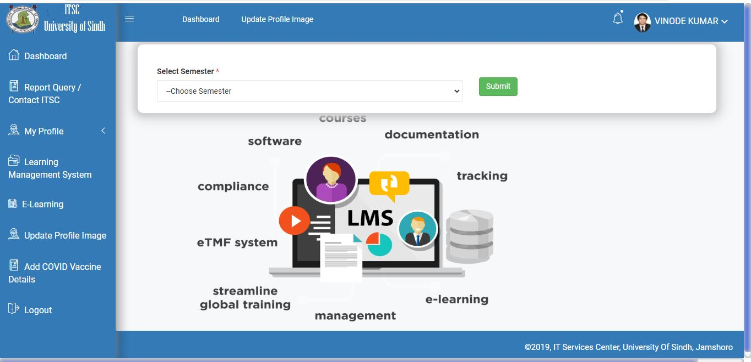

Figure 2.1 ITSC Website

### 2.2.2 MIT COURSE NOTES

### MIT course notes is an web based application which has course material of different subjects of Information Technology. It is kind of similar project but it has course material according to criteria of their university but our project have course material according to criteria of our institute FET.

### 

Figure 2.2 MIT Course Notes Website

Chapter No 3

ANALYSIS AND DESIGN

## REQUIRMENTS

A requirement is a statement of something that is necessary or mandatory in a particular context. It can refer to a specific need or demand, either in the context of a project, a business, or an individual's personal life.

There are several different types of requirements that can be identified and defined in a variety of contexts. Here are two common types of requirements:

### 3.1.1 Functional requirements

These are requirements that specify the functions or capabilities that a product, system, or service should have. For example, in the context of software development, functional requirements might include specific features or actions that the software should be able to perform. FET BASED COURSES MATERIAL MANAGEMENT SYSTEM has the following functional requirements.

* User can be able to login to their account
* User can be able to view course materials
* User can be able to download the course materials
* User can be able to view the Previous FYP projects
* User can be able to post their questions
* User can be able to answer the questions
* Teacher can upload the course material

### 3.1.2 Non-functional requirements

These are requirements that specify the constraints or conditions under which a product, system, or service should operate. Non-functional requirements might include things like performance, security, usability, or reliability. For example, in the context of a website, non-functional requirements might include the requirement that the website load within a certain amount of time.

## DESIGN OF FET BASED COURSES MATERIAL MANAGEMENT SYSTEM

### USE CASE FOR USER

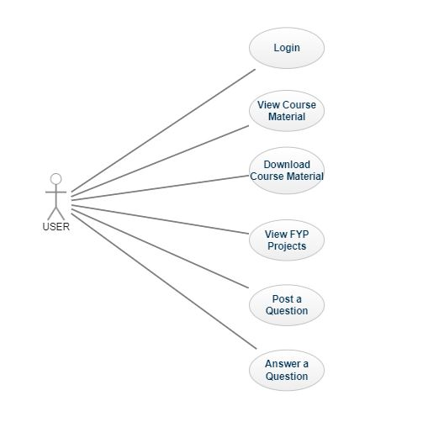

Figure 3.1 Use Case Diagram of User

1. **Use Case: Login**

**In this use case the user can Login to the website using their student id and password which is given to him/her.**

1. **Use Case: View Course Material**

**In this use case the user clicks on course material to view all the course material**

1. **Use Case: Download Course Material**

**In this use case the user can download the course material of their choice by clicking on download button**

1. **Use Case: View FYP Projects**

**In this use case the user clicks on FYP Projects to view the Previous FYP Project of all the departments of FET**

1. **Use Case: Post a Question**

**In this use case the user clicks on Query Section to post questions related to their subjects**

1. **Use Case: Answer a Question**

**In this use case the user navigate to the questions posted by other users and answer them**

### USE CASE FOR TEACHER

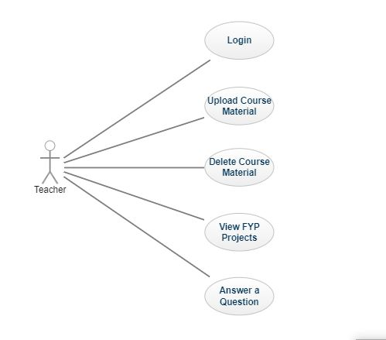

Figure 3.1 Use Case Diagram of Teacher

1. **Use Case: Login**

**In this use case the teacher can Login to the website using their teacher id and password which is given to him/her.**

1. **Use Case: Upload Course Material**

**In this use case the teacher can upload the course material of their desired subjects**

1. **Use Case: Delete Course Material**

**In this use case the teacher can delete the course material of the subjects they upload**

1. **Use Case: View FYP Projects**

**In this use case the teacher clicks on FYP projects to view the Previous FYP Project of all the departments of FET**

1. **Use Case: Answer a Question**

**In this use case the Teacher navigate to the questions posted by other users and can answer them**

## METHODOLOGY

### 3.3.1 Agile Methodology

Agile methodology is a set of values and principles that guide the development of software and other products through iterative and incremental processes. It was originally developed in the early 2000s as an alternative to traditional, Waterfall-style project management, which focuses on rigid planning and sequential development.

In contrast, Agile emphasizes flexibility, collaboration, and rapid iteration. Agile teams work in short, focused sprints to deliver small, usable increments of a product, rather than trying to plan and deliver everything at once. This allows teams to respond quickly to changing requirements and feedback, and to produce high-quality products that meet the needs of the end users.

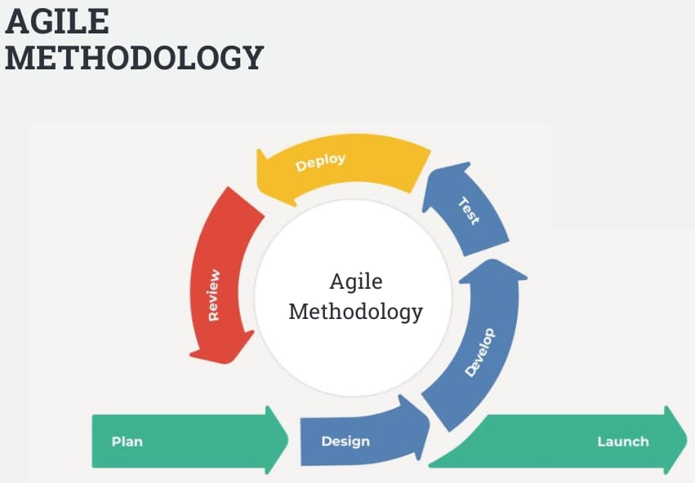

Figure 3.3 Process of Agile Methodology

### Why Agile Methodology?

We have applied agile methodology in our project because we break down the project into several steps, so we can work step by step on each portion. Those steps or components are:

* Data Collection
* Develop UI (User Interface)
* Develop Home Page
* Develop FYP Projects Page
* Develop Query Section Page
* Develop Course Material Section

Chapter No 4

TOOLS AND TECHNOLOGIES

## OVERVIEW OF TOOLS AND TECHNOLOGIES

### FRONT END

* HTML
* CSS
* REACT JS
* MATERIAL UI

### BACK END

* NODE JS
* EXPRESS JS

### DATABASE

* MONGO DB

### DEVELOPING TOOLS

* VISUAL STUDIO CODE

## DEFINATIONS AND ACRONYMS

### HTML

HTML (HyperText Markup Language) is a standardized system for marking up text and media in documents so that they can be displayed in a web browser. It is the primary language used to create and structure content for the World Wide Web, and is used to create and structure documents on the web.

### CSS

Cascading Style Sheets (CSS) is a style sheet language used to describe the appearance and formatting of a document written in HTML (Hypertext Markup Language). CSS is used to control the presentation of multiple web pages at once, making it easy to create consistent and professional looking web pages.

### REACT JS

React is open source front-end JavaScript library for building user interfaces. It was developed by Facebook and has been widely used for building single-page web applications and mobile applications.

In React, developers can create reusable UI components. It uses a virtual DOM (a lightweight in-memory representation of the actual DOM) to optimize updates to the actual DOM, which helps improve the performance of applications. React use a declarative syntax so it makes the code easy to understand for developers.

### MATERIAL UI

Material-UI is a popular user interface library for React that provides a set of React components that implement Google's Material Design specification. It is designed to make it easy to build responsive, accessible, and consistent user interfaces, and it includes a wide range of pre-built components such as buttons, forms, tables, and more. Material-UI also provides a number of customization options, so you can easily tailor the look and feel of your application to match your brand.

### NODE JS

Node.js is a JavaScript runtime built on Chrome's V8 JavaScript engine. It allows you to run JavaScript on the server, which is useful for creating web servers and building server-side applications. Node.js uses an event-driven, non-blocking I/O model, which makes it lightweight and efficient for building scalable network applications. Node.js also has a large, active community of developers who contribute to the development of the platform and create many useful libraries and frameworks that can be used in Node.js projects.

### EXPRESS JS

Express.js is a web application framework for Node.js, designed for building web applications and APIs. It is minimal and flexible, allowing developers to build a wide variety of applications using only a few lines of code. Express.js is built on top of the Node.js HTTP module, which provides a simple, easy-to-use interface for creating an HTTP server and routing HTTP requests. Express.js adds additional features and functionality on top of the HTTP module, such as middleware, routing, and handling of requests and responses.

### MONGODB

MongoDB is a popular NoSQL database that is designed to store and manage large amounts of data efficiently. It is classified as a document-oriented database, which means that it stores data in the form of documents rather than tables with rows and columns. One of the key features of MongoDB is that it is highly scalable and can handle very large amounts of data without sacrificing performance. It is also designed to be flexible, allowing you to store data in a variety of formats, including JSON, BSON, and even binary data like images and audio files.

### VISUAL STUDIO CODE

Visual Studio Code (VS Code) is a free, open-source code editor developed by Microsoft. It is available for Windows, Linux, and macOS. VS Code is designed to be a lightweight code editor, with a focus on providing developers with a fast and efficient code-editing and debugging experience.

VS Code includes a range of features that make it well-suited for writing and debugging code, including:

* IntelliSense: VS Code's intelligent code completion feature that suggests possible completions as you type.
* Syntax highlighting: VS Code automatically highlights different types of code syntax, making it easier to read and understand your code.
* Code formatting: VS Code can automatically format your code according to predefined styles, helping to keep your code clean and consistent.
* Code debugging: VS Code includes a debugger that allows you to step through your code, set breakpoints, and inspect variables.

VS Code also supports a wide range of programming languages, and can be extended through the use of extensions. This allows developers to customize VS Code to meet their specific needs and workflows.

Chapter No 5

IMPLEMENTATION AND RESULTS

Testing is the process of evaluating a system or its components with the intent to find whether it satisfies the specified requirements or not. Testing is executing a system in order to identify any gaps, errors, or missing requirements in contrary to the actual requirements.

There are many different types of testing that can be performed on a software application, including unit testing, functional testing, system testing, acceptance testing, performance testing, and security testing. The specific type of testing that is appropriate for a given application will depend on the nature of the application and the requirements it needs to meet.

Testing is an important part of the software development process because it helps ensure that the application is of high quality and meets the specified requirements. It can also help identify and fix any issues with the application before it is deployed to production.

## 5.1 UNIT TESTING

Unit testing is a software testing technique in which individual units of source code are tested in isolation from the rest of the code to determine whether they are correct. A unit is the smallest testable part of an application. It usually has one or a few inputs and a single output.

Unit tests are typically written by developers as they work on code, to ensure that the code is correct and behaves as expected. The tests are run automatically, and the results of the tests are reported to the developer. If any of the tests fail, the developer can fix the code and re-run the tests until all of the tests pass.

Unit testing is an important part of the development process because it helps to catch bugs early on, before they can cause problems in the finished product. It also helps to ensure that code changes don't break existing functionality, and it can serve as documentation for the code.

## 5.2 FUNCTIONAL TESTING

Functional testing is a type of testing that verifies that a product, system, or component performs the functions that it is expected to perform according to its specifications. It is concerned with testing the functionality of a system to ensure that it is working as intended. This typically involves testing the input-output relationships of the system, as well as the integration of all its components. The goal of functional testing is to ensure that the system is fit for its intended purpose and that it behaves as expected.

## 5.3 SYSTEM TESTING

System testing is a type of testing that verifies that a complete, integrated system meets specified requirements. It is concerned with the testing of the system as a whole, rather than individual components or units. System testing is typically performed after the unit testing and functional testing phases, and it involves testing the system in a simulated real-world environment to ensure that it behaves as expected. The goal of system testing is to identify any defects or issues that may not have been uncovered in earlier phases of testing and to ensure that the system is ready for deployment.

## RESULTS

### 5.4.1 HOME PAGE

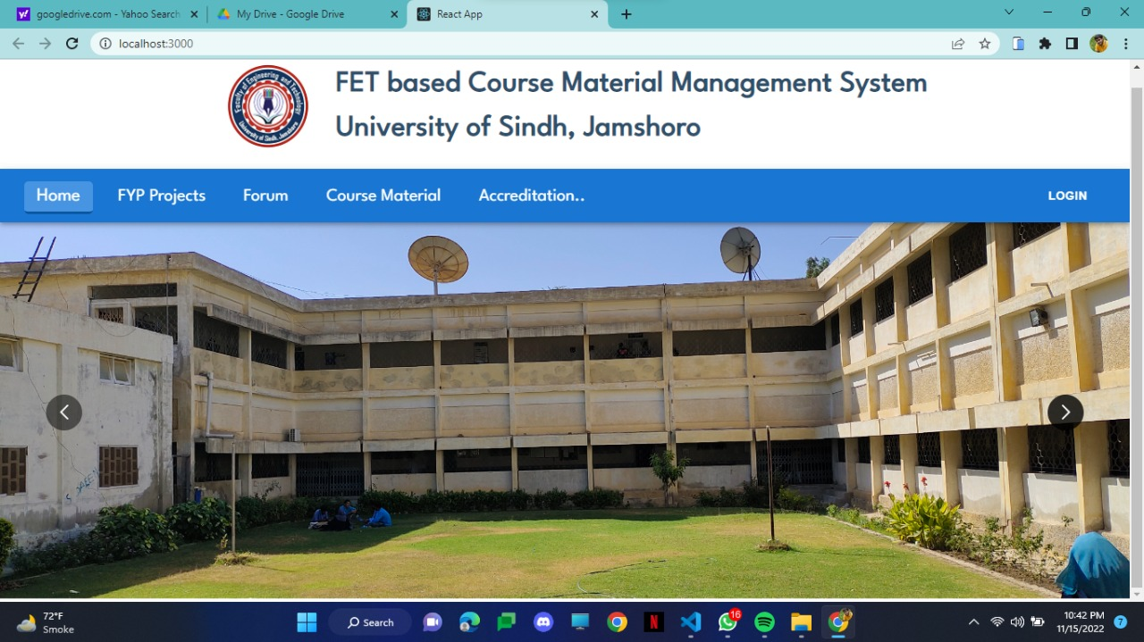

Figure 5.1 Home Page

This figure shows the Home screen, the first screen when a user visits the website. It  
has 3 categories Course Materials, FYP Projects and Query forum each redirecting  
to its respective page. When a user clicks on FYP Projects it will navigate to all the previous FYP projects of all the departments of FET.

### 5.4.2 FYP PROJECTS PAGE

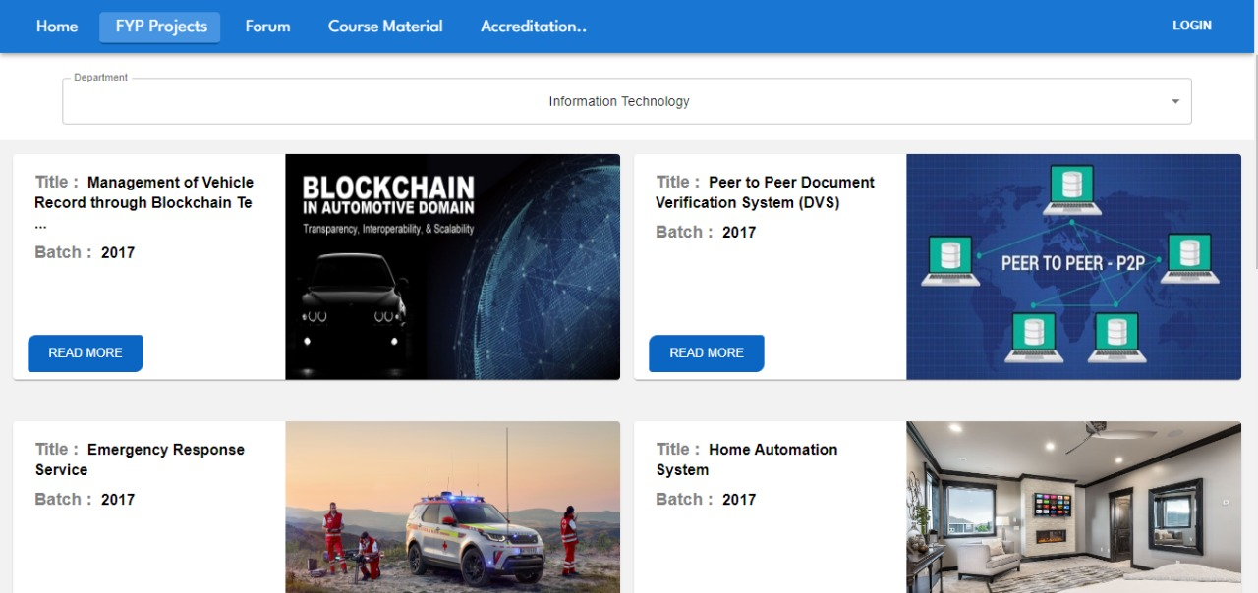

Figure 5.2 FYP Project Page

This page is displayed when a user clicks on FYP Projects from Home Page. This page contains all the previous FYP projects of all the department of FET.

### 5.4.3 PROJECT DESCRIPTION PAGE

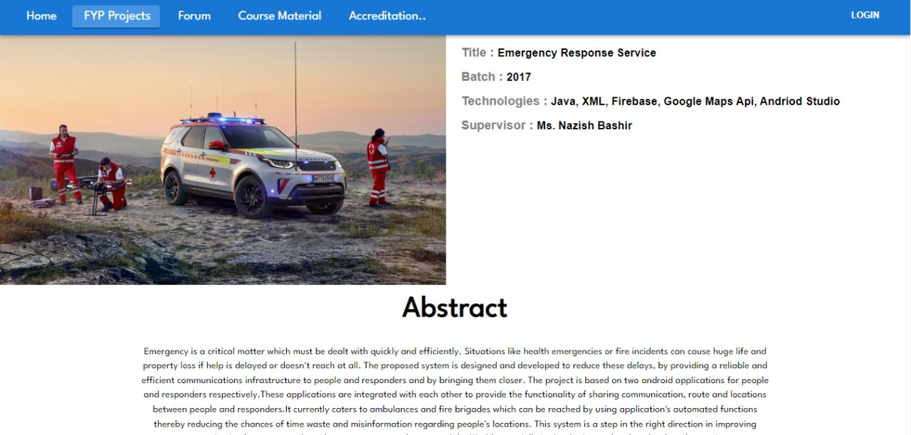

Figure 5.3 Project Description Page

This page is displayed when a user clicks on any project from FYP Project Page. This page shows all the details about the projects i.e. title, batch, tools and technologies, supervisor and abstract of the project. User will get some from these details for selection of their FYP Project

### 5.4.4 STUDENT LOGIN FORM

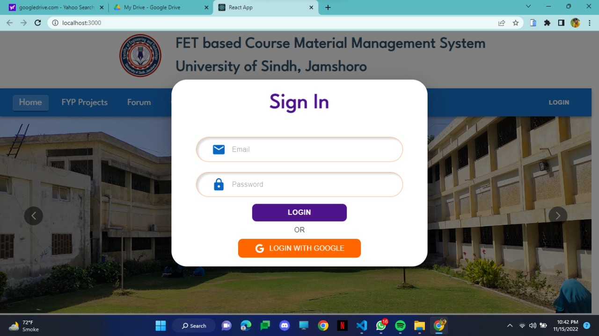

Figure 5.4 Student Login Form

This screen will pop up when a user clicks on login button from Home Page. User can login with their given student id and password.

### 5.4.5 QUERY FORUM PAGE

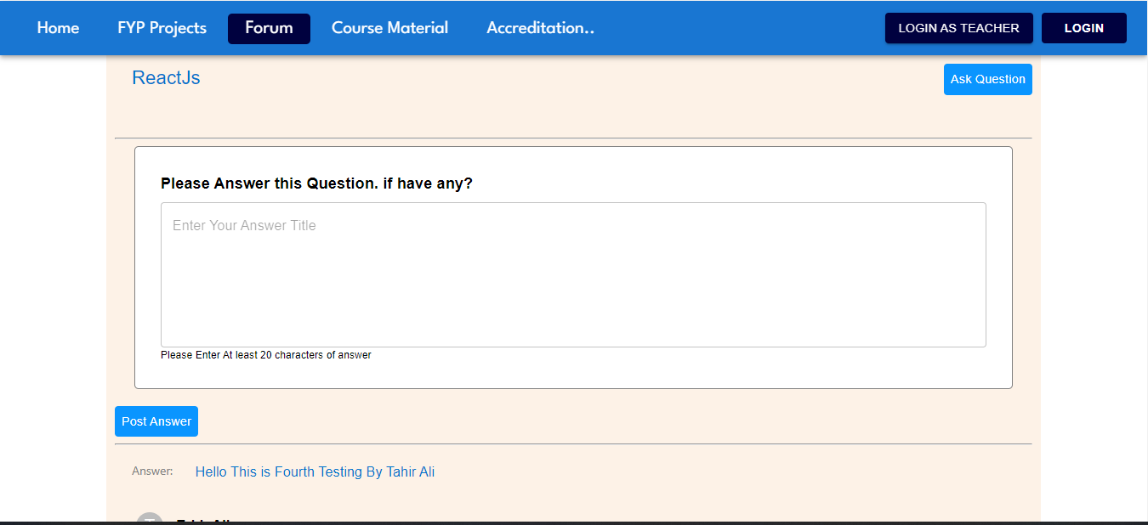

Figure 5.5 Query Forum Page

This page is displayed when a user clicks on Forum from Home Page. In this page the user can post a query related to their subjects or can answer to queries of other users.

### 5.4.6 TEACHER LOGIN FORM

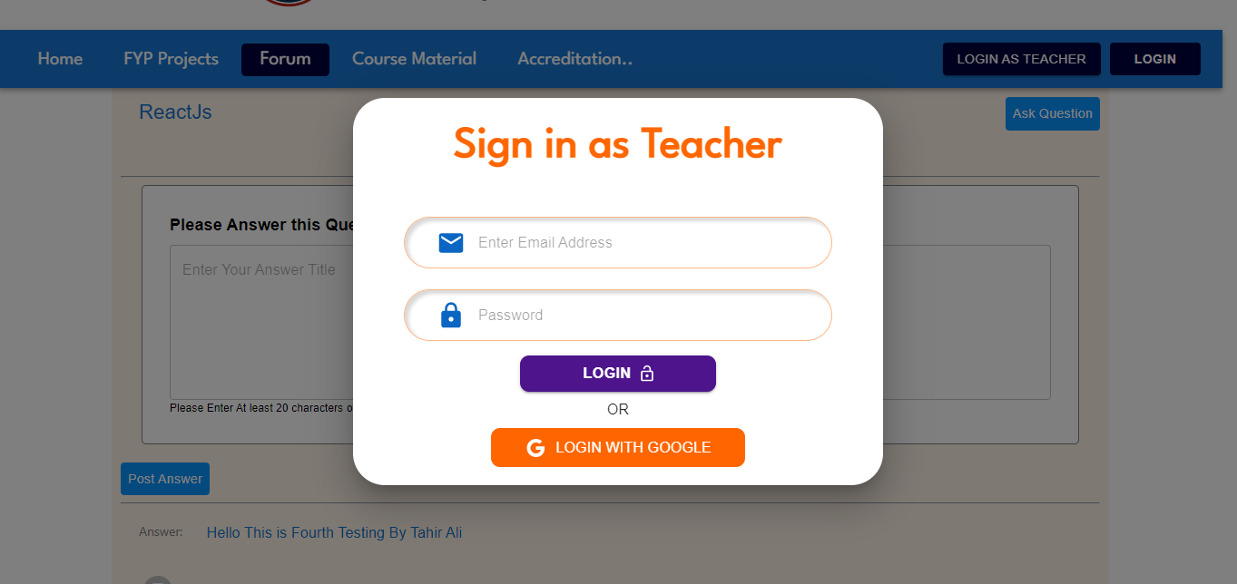

Figure 5.6 Teacher Login Form

This screen will pop up when a user clicks on login as teacher button from Home Page. Teacher can login with their given teacher id and password.

### 5.4.7 TEACHER’S DASHBOARD PAGE

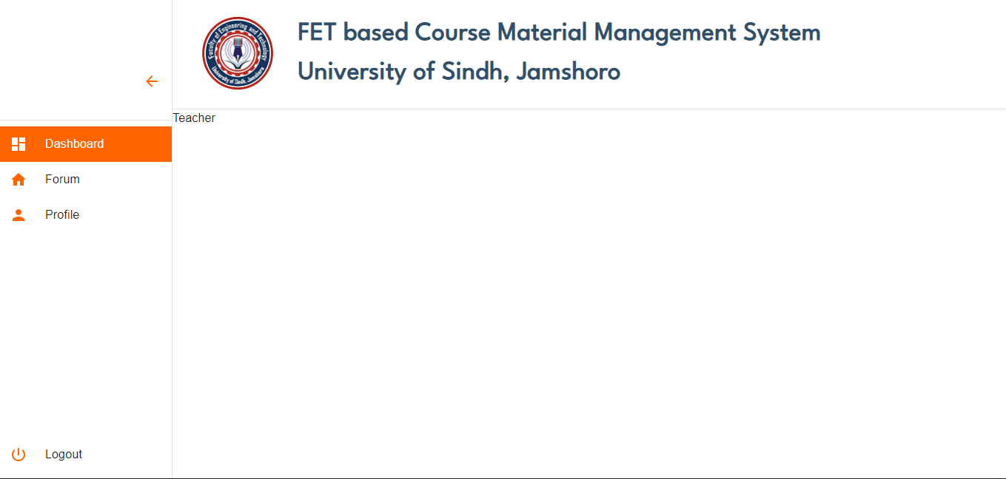

Figure 5.7 Teacher’s Dashboard Page

Teacher will redirect to teacher’s dashboard after input the correct teacher id and password.

Teacher can upload course material of subjects from this dashboard

Chapter No 6

CONCLUSION AND FUTURE WORK

## 6.1 CONCLUSION

In the recent time, there is a need of a web application which will facilitate the students of FET during their studies. So we decide to develop a platform named FET BASED COURSES MATERIAL MANAGEMENT SYSTEM. The primary purpose of this project was to develop a product that will help students of FET during their studies here, so far the results are satisfactory and draws a successful conclusion. The project is working as per the requirements, the students can view the course material and can download it, students can go through previous FYP projects and gain some help from them, also student can post their queries related to their subjects and other students will help them. For teachers, they can upload the course material of their respective subjects only once and refer this material to any of the batches he is teaching. During the development of this project, we were developers who have experienced many unexpected situations. Some of the problems were easy to solve, but many of them were very hard to solve. To achieve success on those problems, we had to do a lot of brainstorming for the ideas and implement different methods. The most significant experience of all was to gain confidence through the difficult situation when it seems to progress impossible. But as mentioned earlier, the brainstorming sessions work very well in this kind of situation. Through this project, we also gained a lot of technical knowledge. Also we want to mention the appreciation, positivity, and support we got from our teachers, which helped us to gain confidence in every difficult situation.

We have successfully developed a platform which will contribute in quality education of Pakistan and help many students during their academics.

## 6.2 FUTURE WORK

For now our project is based on departments of FET, but in future it will be available for all other departments of University of Sindh. We also want to develop a mobile application of this project, so students can access the course material and academic materials with their mobile phone

REFERENCES

[1] <https://itsc.usindh.edu.pk/eportal/public/dashboard.php>

[2] <https://www.cs.uct.ac.za/mit_notes>

[3] <https://chat.openai.com/chat>

[4] <https://en.wikibooks.org/wiki/Introduction_to_Software_Engineering/Testing>

[5] <https://interqualitybg.com/en/resources/scrum-and-agile-resources/agile-methodology>

[6] <https://reactjs.org/>

[7] <https://www.mongodb.com/home>